Order Of Service

Singing: Psalm 38—CW page 81

Reading: Psalm 122

Opening Hymn: TLH 479

Reading: Hebrews 11:32-40

Request Hymn: CW Supplement 748

Reading: Luke 16:1-15

Sermon Hymn: TLH 477

Sermon Text: Song Of Solomon 1:5b

Daughters Of Jerusalem

Prayer

The Apostles’ Creed, TLH page 12

Holy Communion

The Lord's Prayer

The Blessing

Closing Hymn: TLH 478

* * * * * * * * * * *

Koinonia Hour:

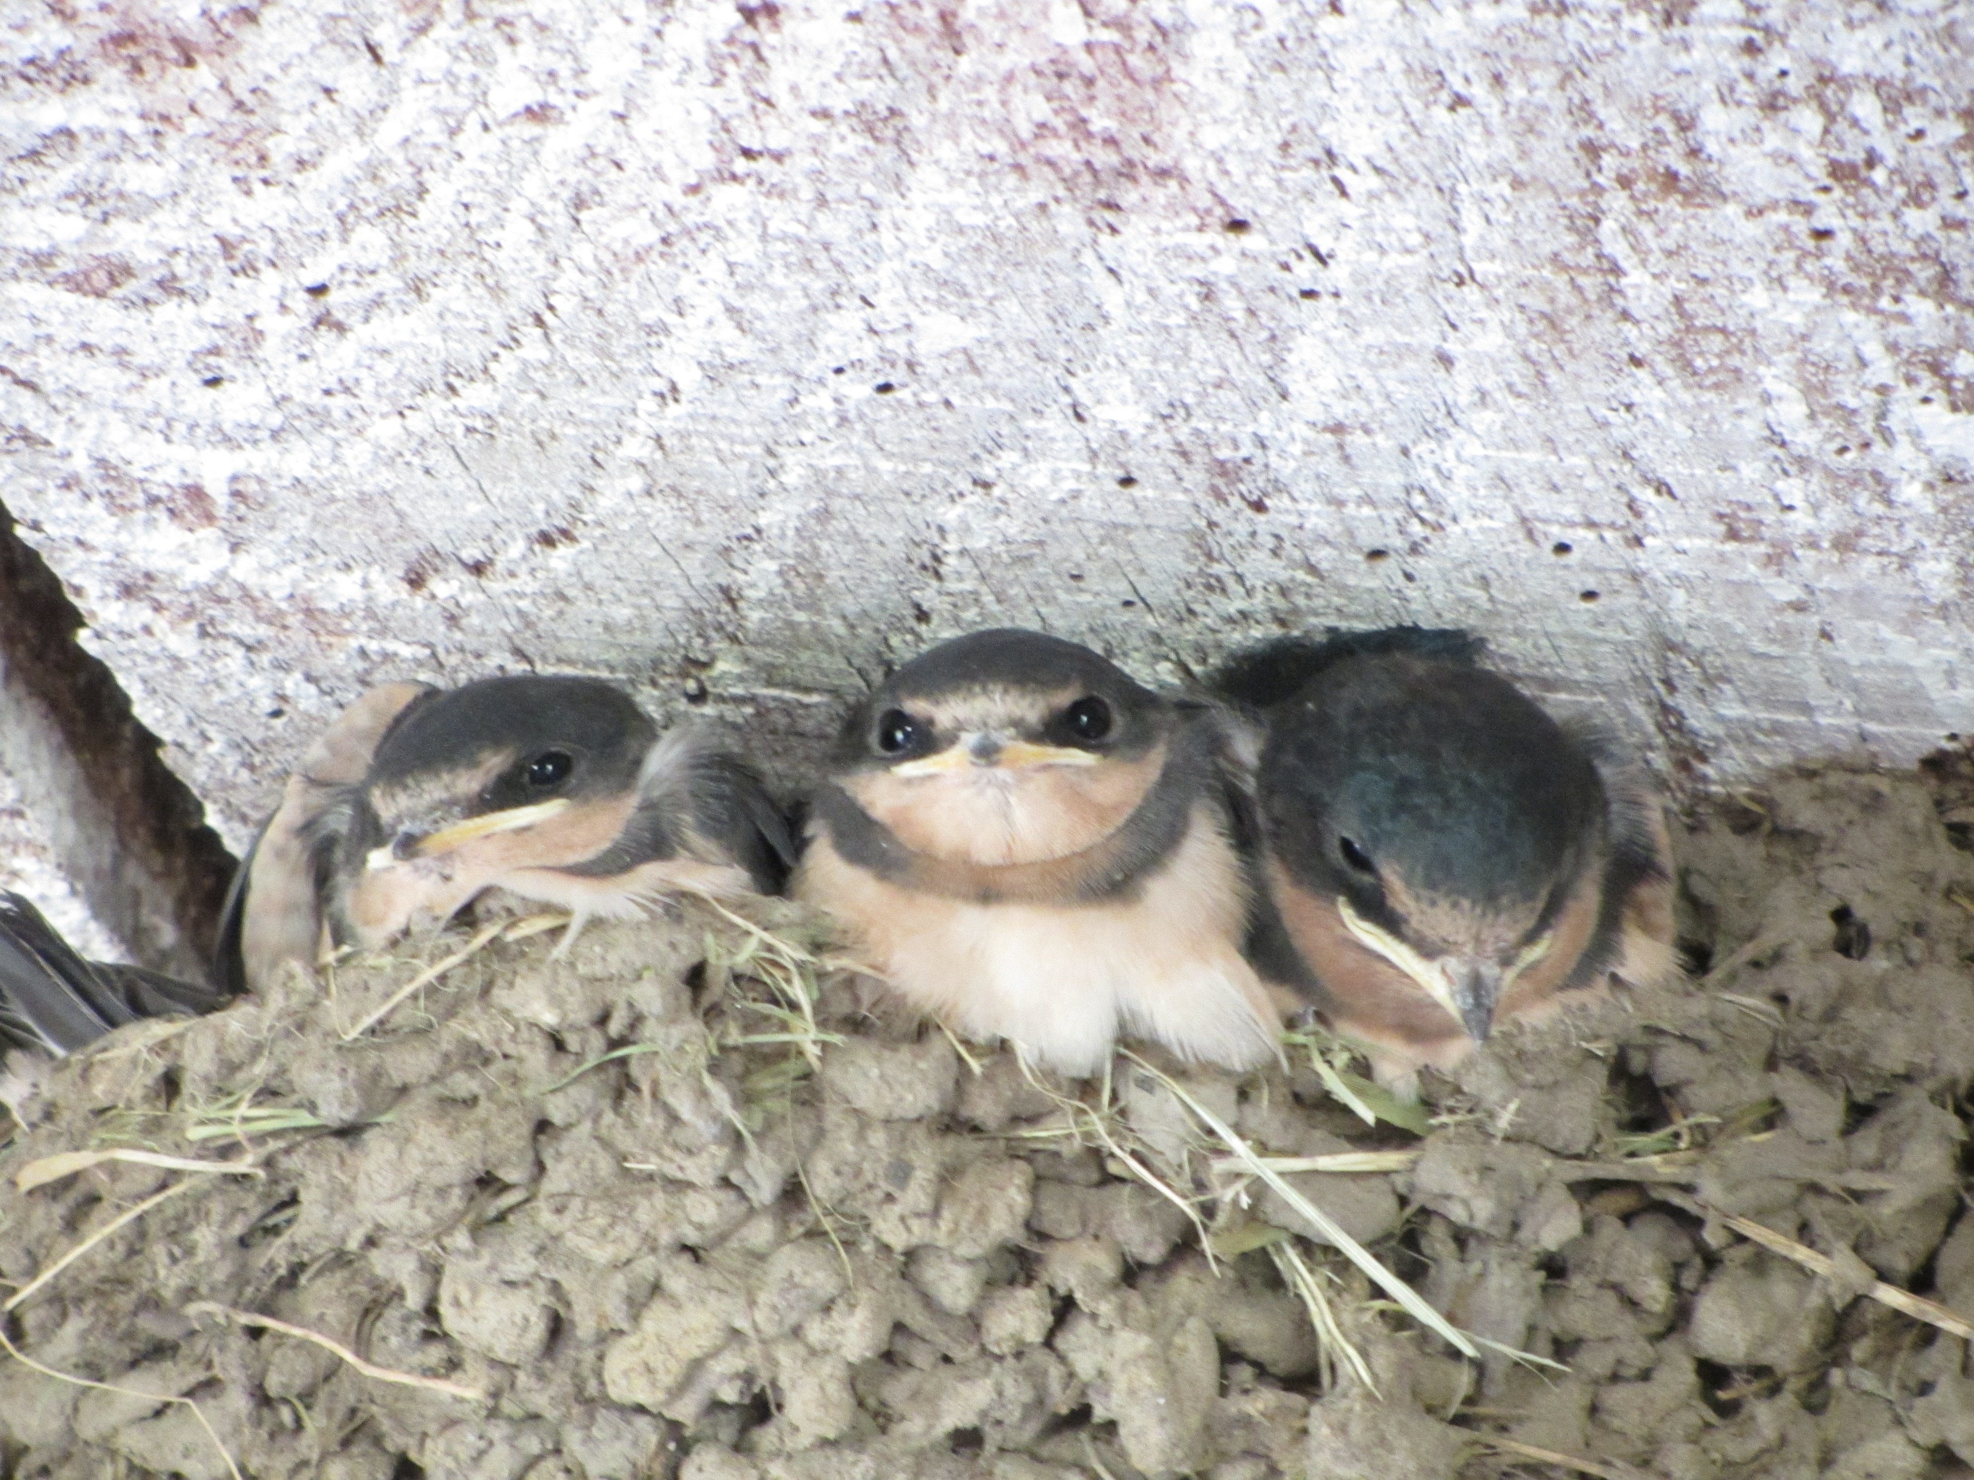

New Hatch

Water
Of
Life

12 July 2015

W A T E R O F L I F E

Independent Christian Church—Conservative Lutheran Doctrine

Worship Service: 9:30 a.m. Bible Study: 10:45 a.m.

Larry Cooper, Pastor E-Mail address:
111 N. Ridge Road lcooper@wateroflife.cc
Coon Valley, WI 54623 Web Site:
Phone: (608) 452-2105 www.wateroflife.cc

* * * * * * * * * * * * * * * * * * * * * * * * * * *

Sermon Text: Song Of Solomon 5b

Daughters Of Jerusalem

* * * * * * * * * * * * * * * * * * * * * * * * * * *

5: I am black, but comely, O ye daughters of Jerusalem, as the tents of Kedar, as the curtains of Solomon.

**************

The opening words of Genesis 3 come as a shock to us on first reading, and they leave us with an unsettled feeling:

Now the serpent was more subtil than any beast of the field which the Lord God had made.
The serpent appears on the scene very suddenly, like a bolt of lightning flashing across the sky. And questions arise: Just who is this creature? How did he get into the Garden of Eden? And why is he speaking to the woman? There is something disturbingly mysterious and unsetting about this scene.

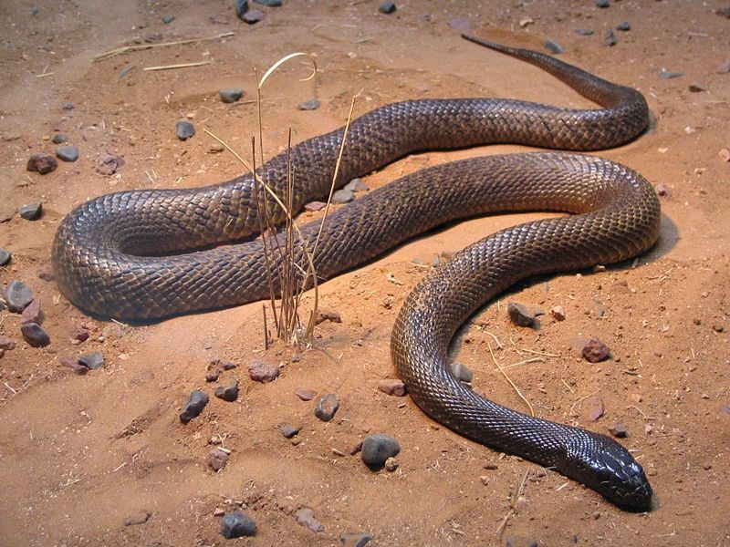

For some reason I get the same feeling about the sudden appearance of the daughters of Jerusalem here in the opening verses of Song Of Solomon. Just who are they? And why does the Bride begin speaking to them? For future reference:

1—The Bridegroom, Christ
2—The Bride, his Church
3—Watchmen
4—Daughters of Jerusalem
5—three score queens
6—fourscore concubines
7—The daughters
8—the mother
9—companions
10—shepherds

